

CSA0501-DATABASE MANAGEMENT SYSTEMS

LAB EXPERIMENTS DATE: 14/07/2026

EXPERIMENT 4 -- DML Commands (UPDATE, DELETE)

AIM:

To perform DML commands such as UPDATE and DELETE on a table with constraints.

PROCEDURE:

Create a table with required attributes and constraints.

Insert records into the table.

Modify existing records using the UPDATE command.

Remove records using the DELETE command.

Display the updated table records using the SELECT command.

PROGRAM:

1. TABLE
USE pet_management;
SELECT *FROM pet_details;

OUTPUT:
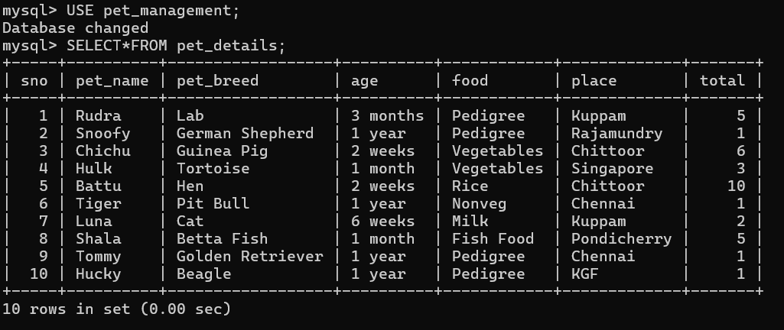

2. UPDATE COMMAND:

UPDATE pet_details
SET age = '4 months', food = 'Pedigree & Rice'
WHERE sno = 1;

SELECT * FROM pet_details WHERE sno=1;

OUTPUT:
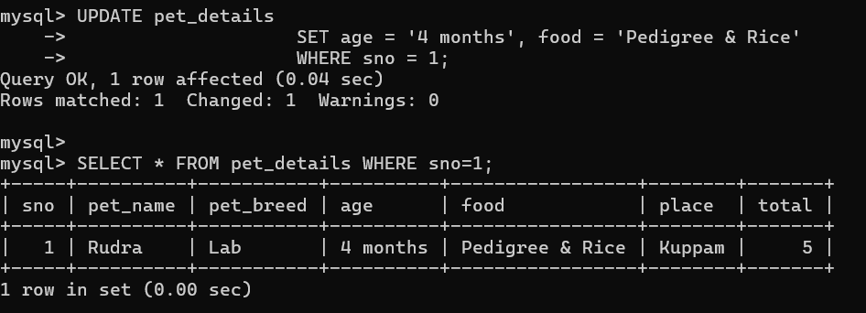

3. DELETE COMMAND:

DELETE FROM pet_details
WHERE sno = 10;

SELECT * FROM pet_details;

OUTPUT:

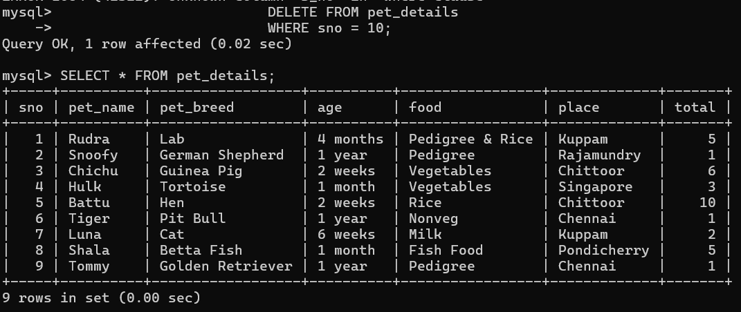

RESULT: Data Manipulation Language (DML) Commands such as UPDATE, DELETE are performed

